**Load balancer service:**

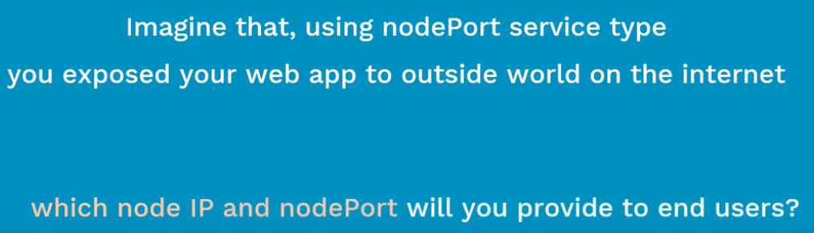

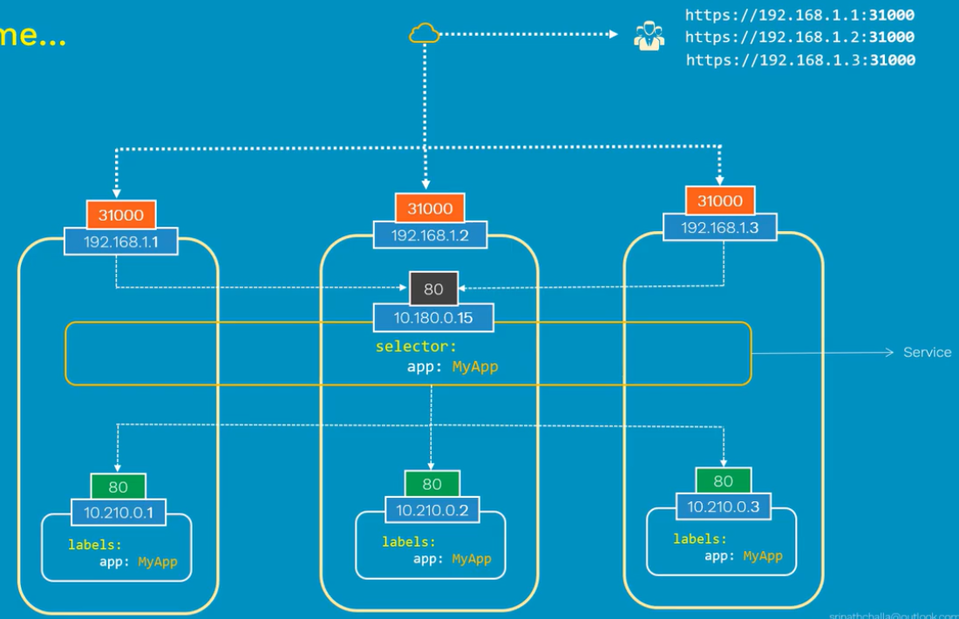

As above, we can access the application with any of the node IP and port.

But we can’t give these IPs to client. And the traffic between these nodes won’t happen also. We need some load balancing on this.

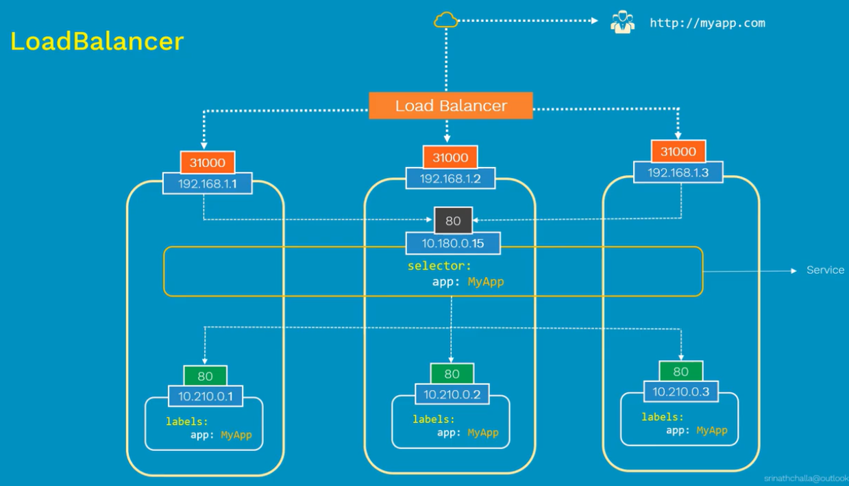

As above, when we create a service type load balancer. It will automatically assign a public IP and route the traffic equally. If support all TCP, UDP traffics.

Load balancers are very expensive. We need to be careful while creating these.

The best solution for this is ingress.

**Manifest:**

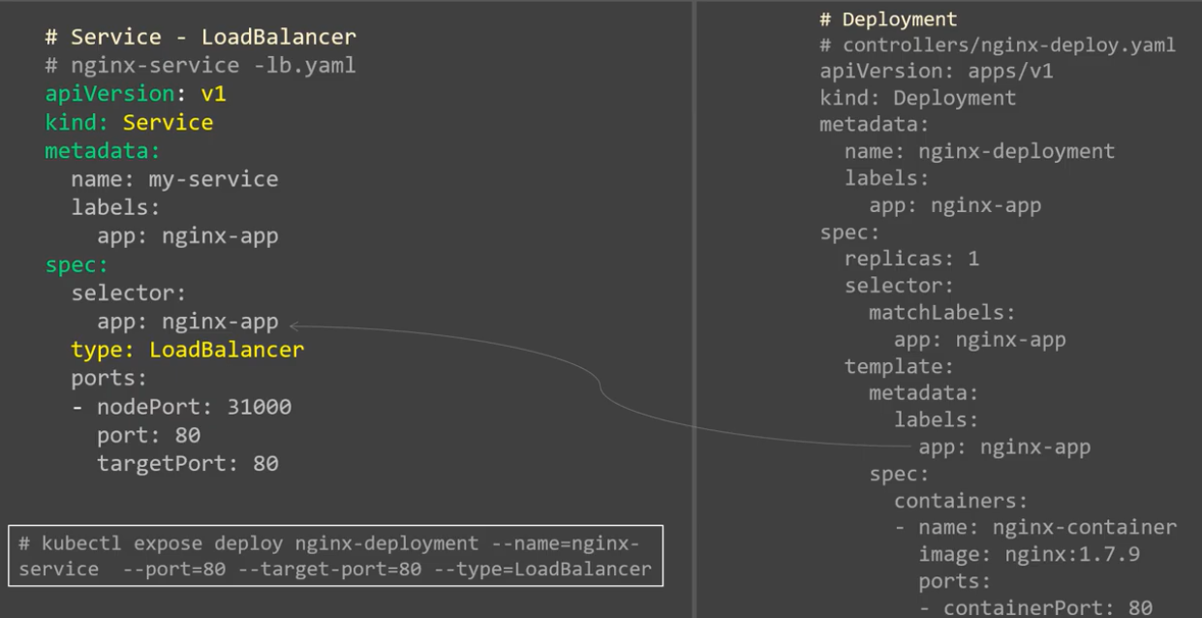

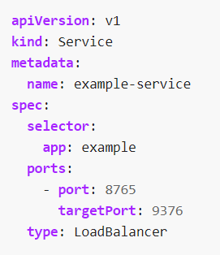

**Create & display:**

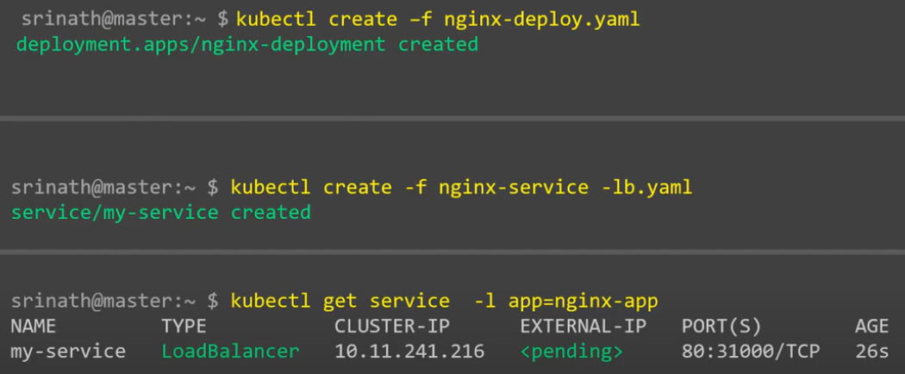

As above, it will take few mins to generate the public IP.

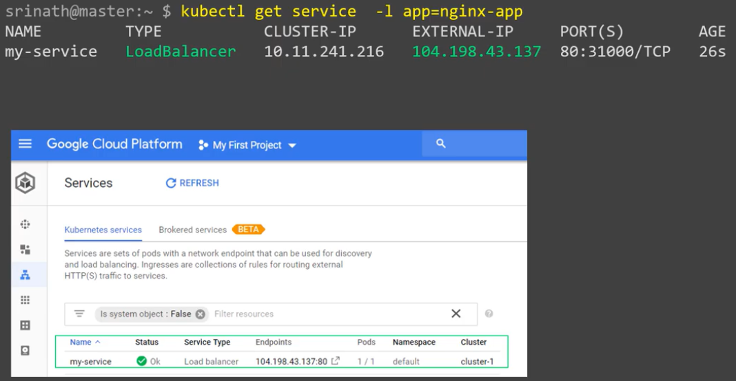

**Describe:**

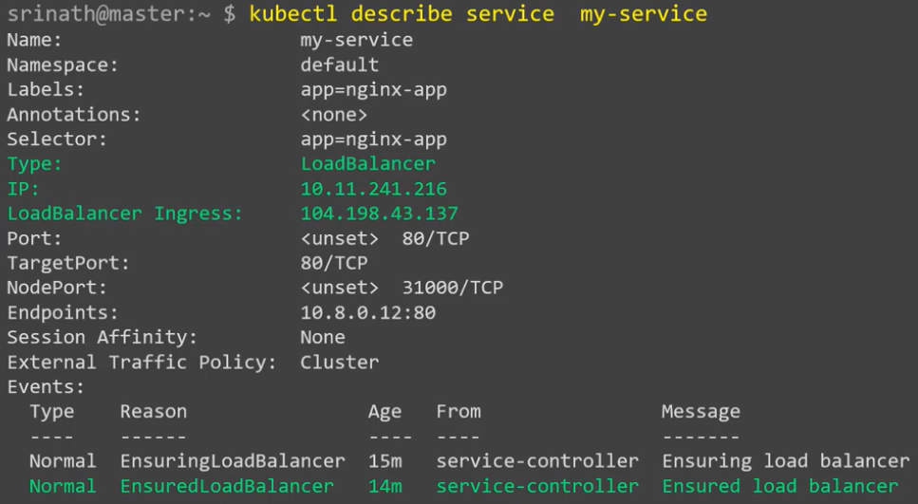

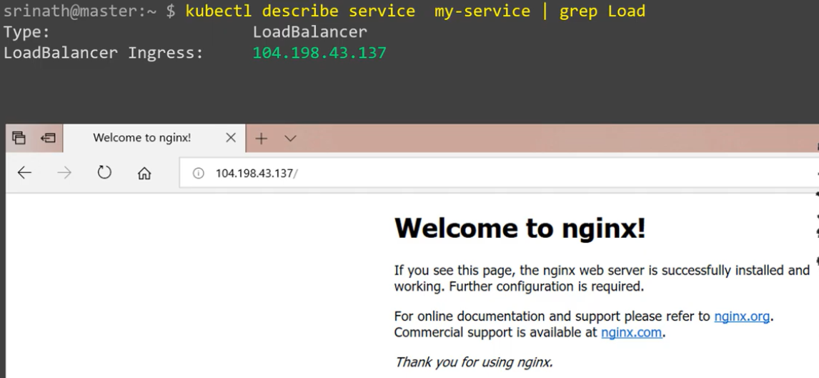

This IP can be accessible from the internet now as above.

**Clean-up:**

Pods will be automatically deleted when we delete the service.

